**Name -Monika Gariya**

**Email-** [**monikagariya2023@gmail.com**](mailto:monikagariya2023@gmail.com)

**Data Engineering Batch 1**

**Date – 22-02-2024**

**TOPIC - Introduction to azure devops**

**What is Azure DevOps?**

Azure DevOps is also known as Microsoft visual studio team services (VSTS). It is a set of collaborative development tools built for the cloud Azure DevOps provides an integrated set of services and tools to manage your software projects, from planning and development through testing and deployment.

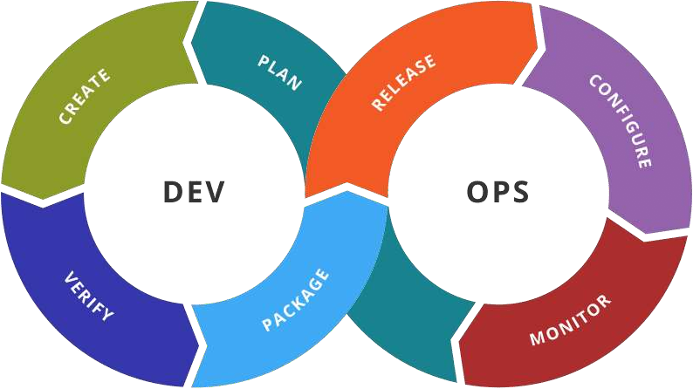

**Azure Boards**

Azure Boards is a web-based service that enables teams to plan, track, and discuss work across the entire development process, while it supports [agile methodologies](https://learn.microsoft.com/en-us/azure/devops/boards/work-items/guidance/agile-process?view=azure-devops). Azure Boards provides a customizable platform for managing work items, allowing teams to [collaborate](https://learn.microsoft.com/en-us/azure/devops/cross-service/cross-service-overview?view=azure-devops) effectively and streamline their workflow.

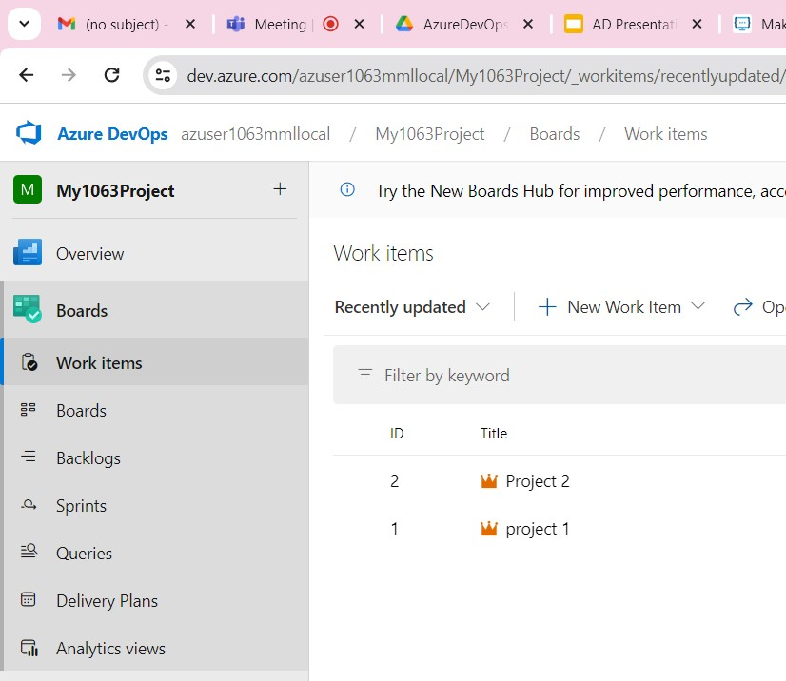

# **Azure DevOps Repos**

Azure Repository is a set of version control tools that we can use to manage our code. In case if we are entirely new to version control, then version control enables us to track changes we make in our code over time. There are so many software that is available in the market to enable version control on our code. We can use the version control system to keep track of each change done by each developer, safely merge them, test the changes, and publish the change into production.

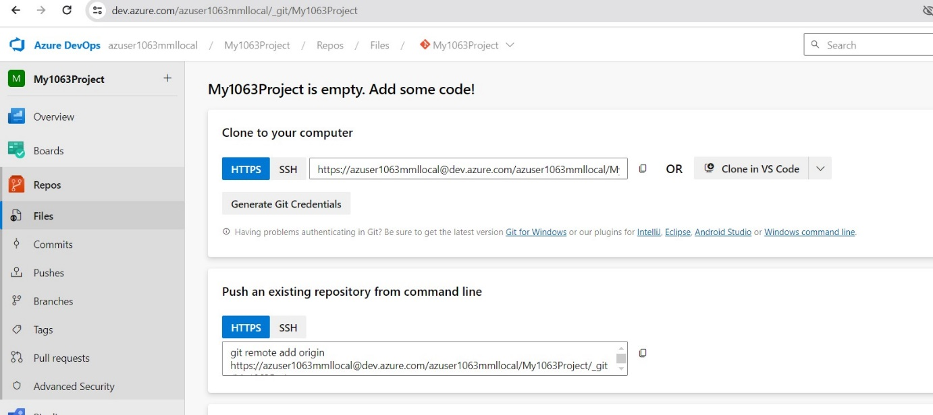

# **Azure Pipelines**

Azure Pipelines automatically builds and tests code projects. It supports all major languages and project types and combines [continuous integration](https://learn.microsoft.com/en-us/azure/devops/pipelines/get-started/what-is-azure-pipelines?view=azure-devops#continuous-integration), [continuous delivery](https://learn.microsoft.com/en-us/azure/devops/pipelines/get-started/what-is-azure-pipelines?view=azure-devops#continuous-delivery), and [continuous testing](https://learn.microsoft.com/en-us/azure/devops/pipelines/get-started/what-is-azure-pipelines?view=azure-devops#continuous-testing) to build, test, and deliver your code to any destination.

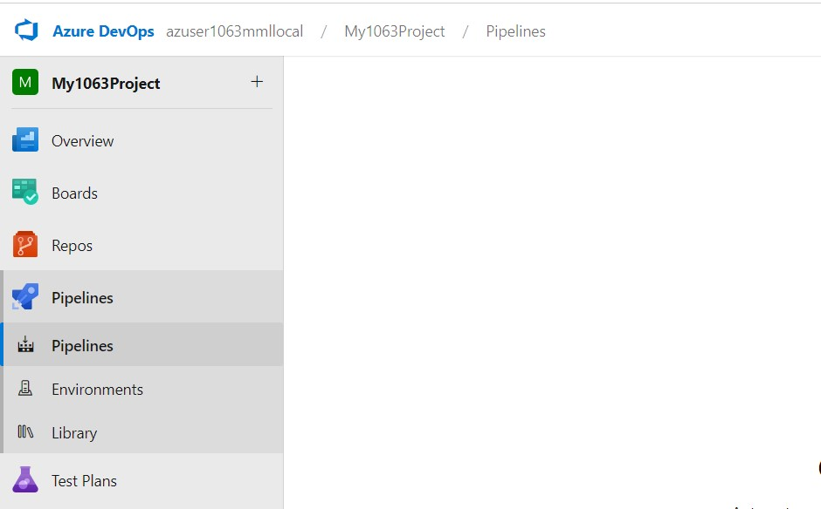

**AZURE TEST PLANS**

Azure Test Plans is is a test management module within Azure DevOps that lets users manage test plans, test suites, and test cases for everyone in the software development process. Using test plans, you can Azure Test Plans also provides a browser extension for exploratory testing and gathering feedback from stakeholders.

**AZURE ARTIFACTS**

Azure Artifacts enables developers to efficiently manage all their dependencies from one place. With Azure Artifacts, developers can publish packages to their feeds and share them within their team, across organizations, and even publicly across the internet. Azure Artifacts also allows developers to consume packages from different feeds and public registries such as NuGet.org or npmjs.com. Azure Artifacts supports the following package types: NuGet, npm, Python, Maven, Cargo, and Universal Packages.